**Bearded Collie Club of America   
Board of Directors Meeting Minutes  
Tuesday, August 20, 2024 at 8:30 PM ET**

1. **Call to Order at 8:33 PM**  
2. **Roll Call:** Barnes, Beddoe, Bond, Colombo, Jamison, Means, Minner, Norteman, Poliak

**Absent:** Edwards, Gracie

3. **Report of the Treasurer**The Treasurer's Report documents are included in the emailed Board packet.

Taxes are at the accountant’s. Renewals are still in process. Late notices went out 8/1. 65% paid, so 151 members had still not renewed as of the time of the meeting. This is a higher number than last year. Board members will contact people who have not renewed. Don will send out the list.

40% of members who responded want printed Rosters.

Next year: Suggest we add an option to the renewal form for “I don’t want to renew.” This saves the Board from having to call people.  
  
4. **Report of the Corresponding Secretary**

**General Notes**

* Contact information update:

Maryann & Augustine Carre

248 Farmington Blvd

Winchester, VA 22602

540-333-2530

**AKC Notes**

* Submitted medallion sponsorship to AKC for December Royal Canin national championship and invitationals for Obedience, Rally, Agility and Conformation ($260). These items are included in the approved budget, therefore no motion was required for their sponsorship.
* Approval for Bob Lamm as delegate granted in October AKC delegates meeting. Next delegate meeting is September 10.

We have two new membership applications to vote on this month. See New Business.

Showsight is featuring Beardies in September, especially versatility, judging. They are looking for articles or ideas to include. Casey reached out to some people but hasn’t had a response.

**5. Old Business**

**2024 Specialty**

Registration is open, with Logowear coming soon. Lisa is setting up locations for the Welcome Party and Closing Ceremony. Once these have been finalized, the committee will produce a map for Specialty-goers.

**2025 Specialty**

The committee will report next month. All major chairs identified. Working on contracts, moving along.

**2026 Specialty**

The hotel contract was signed, and the day-of show secretary has been signed. Contracts are signed for the agility equipment and the timer.

Lisa Voss is heading Welcome Bags, and Dawn Mieras is heading the Breeders Showcase.

**Obedience Committee Chair**

Following up: Still searching for a new Obedience Committee Chair. Joanne will do the stats. Pat is searching for a co-chair to work with her. Should be set by next month.

**Standing Rules Update**

Following up – discussion about how to fairly allocate BCCA event licenses. Preference might be given for the National Specialty host club – first priority would be the host club, unless they had their own licenses.

Sue will take a first pass at a rule, based on Carol’s first draft.

**Membership Renewals**

Membership renewals opened by July 1 and will close by August 31. Both the online renewal form and the PDF form are available.

Roster: Michele will first finish the Specialty work, and will then get to the Roster. Question: How will the Rosters get printed/mailed/delivered? Rosie can run the mailing labels. Pat or Sue will get them into the mail.

**6. New Business**

**Applicants to vote on, August 2024**

Melody McCloud

Single Associate membership

Tulsa, OK 74104

Email: mmccloud300@gmail.com

Occupation: Retired

Has had bearded collies for 25 years and owns one now. Joining to keep current on activities and events specific to Bearded Collies, to include training, education, resources and to build network of friendships of other Beardie owners and breeders. needed. Has operated in a leadership role and participated in her local dog club as Registrar for class enrollments, Agility Instructor and Board Member. Can assist at agility trials. First Bearded Collie in 1999 was a rescue from BCCA and president at the time was Paul Glatzer.

Sponsor: Claudia Diaz

Halle Hadel & Nathan Keisow

Joint Full membership

North Fond du Lac, WI 54937

Email: hallehadel@gmail.com

Second Member Email: keisownate@hotmail.com

Occupation: Education Program Coordinator

Occupation2: Supply Chain Professional

Have 2 bearded collies and have owned for 1 year, but been involved with caring for beardies for 7+ years. Currently co-own Siberian huskies who do not live with them. Has been in conformation training and breeding siberians for 21 years (owned by family). Looking for opportunities to become more involved in the breed and continue to learn and meet new people. Most familiar with conformation, but interested in other sports and willing to learn.

Sponsor: Cheryl Poliak

Both applications were approved.

**AKC Canine College**

The Board needs to approve the photos and videos for the AKC Canine College program on the Bearded Collie. The committee went through the photos and videos to select the final materials to be produced and available to judges.

Board voted to not approve the Canine College materials due to low quality.

**AKC Donor Advised Fund Statement**

The following statement shows BCCA’s contribution through the Purina Pro Club program:

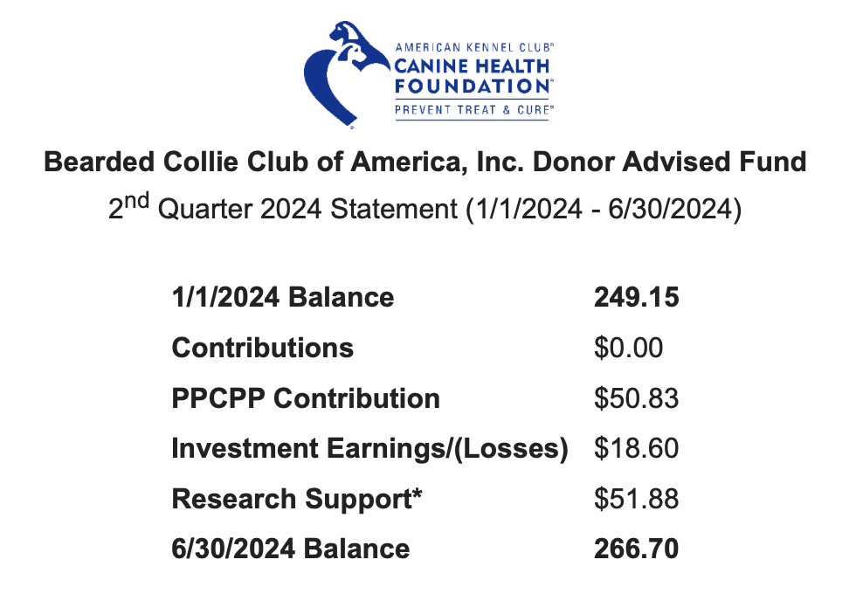

**New Standing Rule for Affiliate Club Grants**

We need to make a standing rule of the club grant of $500 per affiliate club per year, along with rules and guidelines about requests and use. Money for these grants is in the budget for 2025. The pilot program for the grants runs from September to September, but should be aligned with the club’s fiscal year, if the Board approves. Casey will contact Michele about putting the information in *Bagpipes*.

Casey will write up a description of the pilot project and that one club used it successfully. The description will appear in the next month’s Bagpipes. The actual rule will be voted on in September, to go into Bagpipes in October. Casey will contact the club secretaries.

**2026 National Specialty Judges**

The nomination period is open, but it closes September 1. We have only a few nominees this time, almost all of whom were on the ballot for the 2025 Specialty.

**Unlicensed Judge Form**

BCCME needs to file a request form for an unlicensed judge with AKC. The form is ready to be signed and filed with Event Operations.

The meeting was adjourned at 9:50 PM.

**Next Meeting: September 17, 2024 at 8:30 PM**